**Project Members**

1. Sakib Haider

ID: 2020-1-60-104

1. Ariful Islam Fardin

ID: 2020-1-60-111

1. S. M. Sabbir Sobhani

ID: 2020-1-60-088

**Graph Plotting: Number of Cache Vs Hit Count**

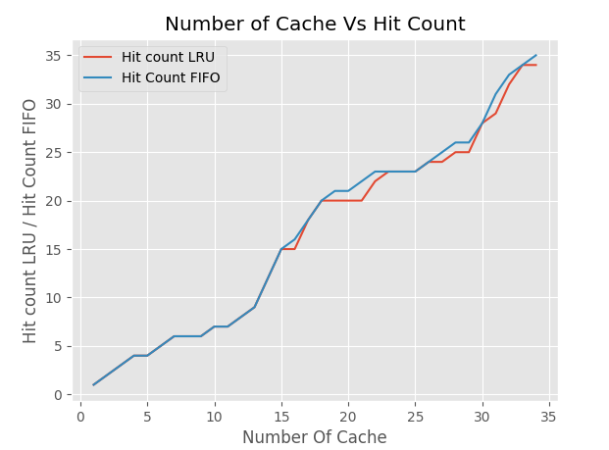

**Graph Plotting: Number of Cache Vs Miss Count**

